EECE 5520 Microprocessor II Embedded System Design

LAB 2 Game Control with Joystick, Gyro and Accelerometer

Professor Liang-Min Wang

**Team Members**

Bhargavi Upperla ID: (02006085)

Rishab Vyas ID: (02008386)

Jairus Morrow ID: (01873039)

**Purpose**

This lab is to design a game controller for a “Snake” game. The “snake” in the game needs to eat the apples that randomly appear in the arena. The snake can move in four directions: up, down, left, right. It grows its length by one unit every time an apple is eaten, and the player earns 10 points. The snake cannot hit the boundary of the arena. The game ends when the snake hits onto the boundary. The game (a python script) is initially controlled with four keys on the keyboard: “w”, “a”, “s”, “d”. Your task is to alter the control (an Arduino application) of the game with the following:

**Objectives**

1. Use a joystick to control the movement of the snake
2. Use the gyro sensor (MPU-6050) to control the movement of the snake. For example, tilting the sensor board to the left will cause the “snake” to move to the left.
3. Beep the buzzer when an apple is eaten

*Additional requirements for EECE.5520 students*

1. “Shake” the accelerometer to double the number of points for eating an apple. To do that, you need to measure the acceleration from the sensor (MPU-6050), design a criteria (algorithm) to detect if the sensor is being shaken, if so, notify the game to double the points for the next apple (so now 20 points per apple). After the next apple is eaten, revert the points back to normal (10 points per apple).
2. You need to change the color of the apple to “golden” to indicate the points are doubled for the new apple. Then change the color back to red after the golden apple is eaten.

**Team Member Responsibility**

*Bhargavi Upperla* – Tasked with constructing the Game Control with Joystick, Gyro and Accelerometer. Implemented serial streaming code from Arduino to Python.

*Rishab Vyas* – Tasked with creating the code to interpret the joystick movements. Implemented buzzer function.

*Jairus Morrow* – Tasked with creating the schematic and creating the code to interpret MPU-6050 position data. Created code for bonus mode.

**Materials**

|  |  |  |
| --- | --- | --- |
| **Game Control with Joystick, Gyro and Accelerometer BOM** | | |
| ***REFERENCE DESIGNATOR*** | ***QTY*** | ***DESCRIPTION*** |
| U1 | 1 | Arduino Mega 2560 |
| U2 | 1 | Joystick |
| U3 | 1 | MPU-6050 |
| BZ1 | 1 | Active Buzzer |

**Schematic**

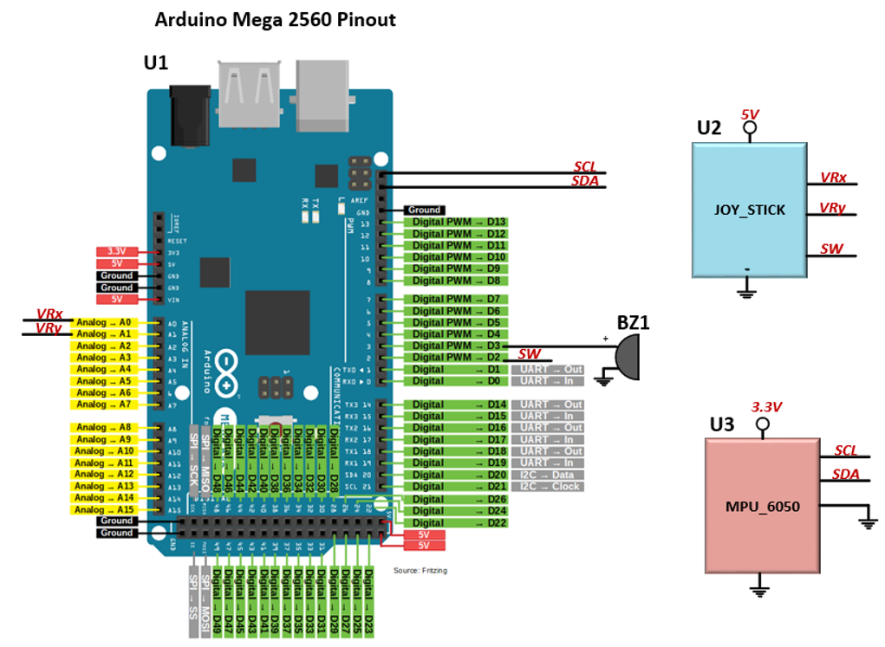

**Results & Conclusion**

For this project we needed to determine how to send data through the serial port and have python interpret the data being transmitted. The raw values for the joystick and the MPU-6050 fluctuated at rapid rate. Because of this we needed to classify specific ranges and transmit definite values for python to interpret. (e.g. Left = ‘D133’ and Right = ‘D233). Position zero (‘D’) is the start of each data stream. Position one is the left-right data. Position two is the up down data. Position four is the bonus mode data. Secondly, we had to set the delay time of the Arduino code to match the clock speed of the Python code. Finally, we successfully created the snake game using the pygame library. All objectives were completed.

YouTube Video Link Demonstration: <https://youtu.be/6onnkIBmaUo>

GitHub Link: <https://github.com/rishii2098/Game-control-with-joystick-Gyro-and-Accelerometer>